**2021F CSD 1103 - Front End Web Development I**

**Practice Exercise 5**

**Question 1: (this question gives you 1 point)**

Create a structure of a webpage, with html, head and body sections. In the head section, use title element to provide a title (your name-student id-assignment 5-1). In the body, create a table that matches the following table (borders and caption added as shown):

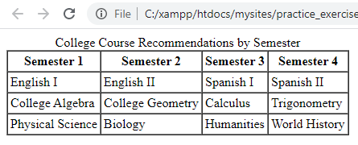

**Submission:**

* Your HTML file.
* For CSS, if you use external CSS, then submit your CSS file as well (otherwise include CSS rules in your HTML file as appropriate, using <style> tag or inline styles)
* The screenshot image file showing how your web page is rendered in the web browser (Filename scr5-1.jpg)

**Question 2: (this question gives you 2 points)**

Create a structure of a webpage, with html, head and body sections. In the head section, use title element to provide a title (your name-student id-assignment 5-2). In the body, create a form that matches the following form (for form submission GET method must be used, for submission URL myform.php must be used):

Note that 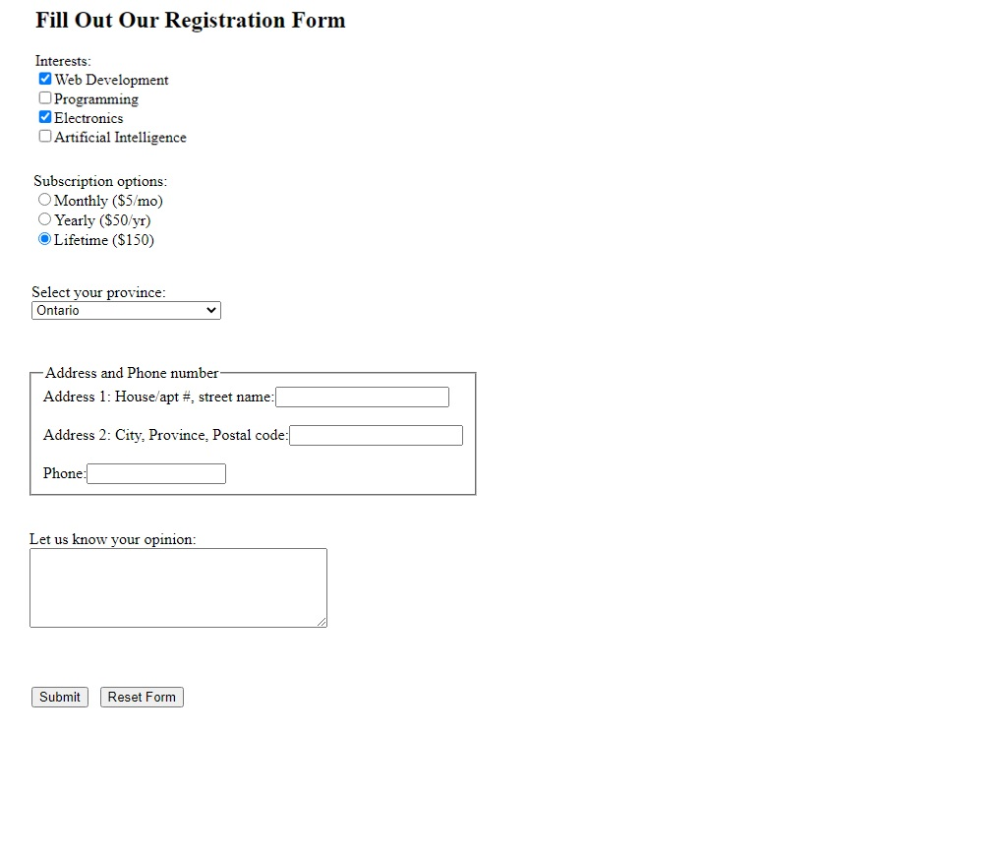

*Note*: Clicking on a label of a checkbox or a radio button form control must act as clicking on the corresponding form control.

**Submission:**

* your HTML file
* your CSS file (if any)
* screenshot image file, showing how your web page is rendered in the web browser. Filename: scr5-2.jpg.